**Related Cases TO BE steps:**

1. Go to ‘Related Cases’ tab

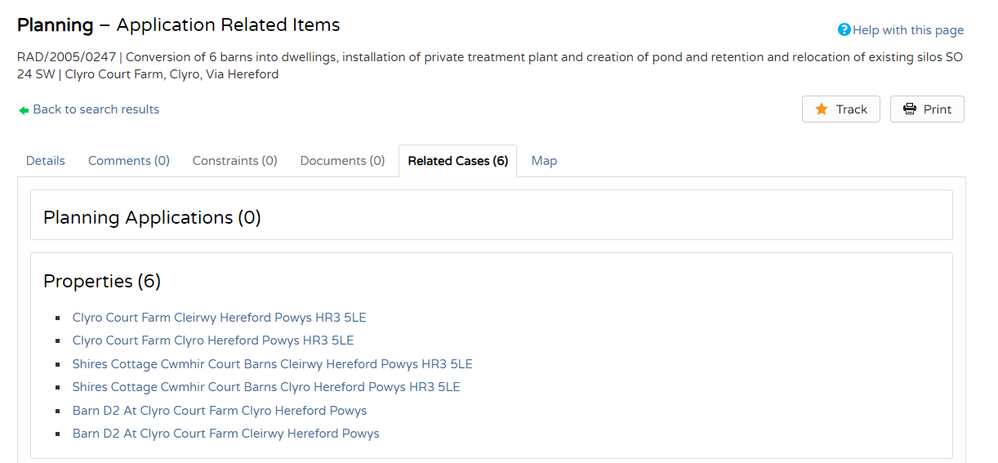

1. In ‘Properties’ choose 1st line item (duplicate line items are there so choose odd or even line items)



1. Go to ‘Property History’

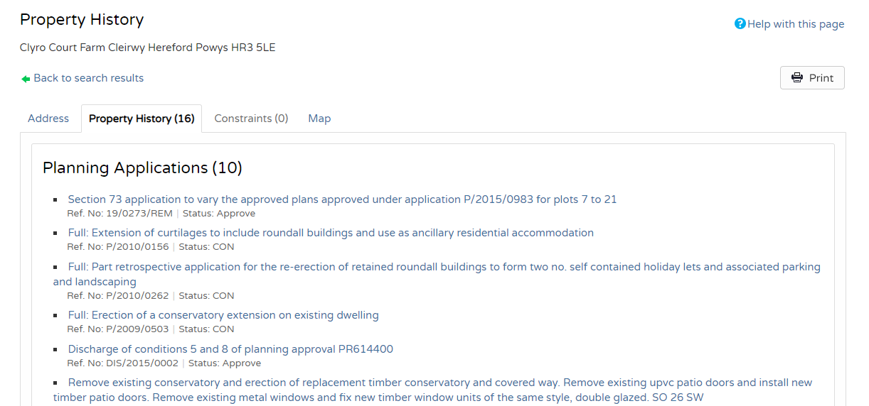

1. Open the first link for latest update



1. In ‘Summary’ extract the following data
   1. Reference, Proposal, Location, Decision, Decision Date

